Enrolment Policy

Purpose:

- To ensure that Melton Primary School meets its DE requirements and enrols all eligible students
- To ensure that Melton Primary School maintains a safe environment that caters for the needs of all its enrolled students
- To ensure that Melton Primary School maintains an enrolment level that does not adversely impact upon student learning due to playground spaces and class sizes
- To ensure that Melton Primary School does not unduly affect the enrolments of other schools within the Melton area

Implementation:
- Children of school age have the right to be admitted to their designated neighbourhood government school at the beginning of the school year unless an approved alternative placement has been arranged.
- When a family moves into the area during the school year the children of school age have the right to be admitted to their designated neighbourhood government school unless an approved alternative placement has been arranged.
- Student transfers between local Melton government schools will only occur for students starting at the beginning of Term 1 or Term 3. Transfers will only be agreed upon after consultation with the current school and only if there is a place available. Refer to ‘Priority Order of Placement’ section of this policy.
School’s responsibility:
Before admitting a student schools must:
- collect relevant admission information (eg, expression of interest form, proof of address)
- obtain a completed enrolment form
- provide a privacy notice to the enrolling parent explaining the use to be made of admission information. For sample notices see: Privacy within Department resources
- collect and record an immunisation status certificate

For admission, all applicants must be:
- an Australian citizen, or a student with relevant specified visas, see: International Student Program
- deemed eligible and approved for enrolment by the principal or relevant regional director.

Melton Primary School will:
- enrol eligible students, who are new to the Victorian government education system under the name contained in the documents supporting their admission; primarily their birth certificate
- keep copies of sighted documents this includes an immunisation status certificate
- verify changes to student enrolment names
- maintain student details and movements in enrolment history
- keep all information confidential and managed in accordance with:
  - the Department’s privacy policy
  - Victorian privacy laws
NB: At initial enrolment a Victorian Student Number (VSN) is allocated to a student in the name certified in admission documents (that of the name on their birth certificate). When students transfer between schools, the subsequent enrolment is in the name attached to the VSN, unless a student has presented documentation to prove they have had their name changed.

Age eligibility and approval requirements:
Regulations establish the minimum and maximum ages for enrolment in government schools.
- Schooling is compulsory for students aged from 6 – 17 years unless an exemption from attendance has been granted. For exemption categories and processes see: Attendance

Enrolment:
The following arrangements apply to new enrolments at Melton Primary School that either:
- can be made by principals without further approval, or
- require regional office or other approval.

Families can type their address into: https://www.findmyschool.vic.gov.au/ to find their local designated neighbourhood school
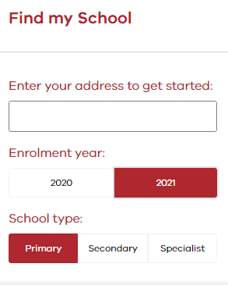

DESIGNATED NEIGHBOURHOOD SCHOOL
The designated neighbourhood school is the school that is nearest the student’s permanent residence, unless the regional director:
- needs to restrict new enrolments at a school
- has designated the neighbourhood boundaries for the school.

The measure of the nearest school (not withstanding if a neighbourhood zone has been put in place) is measured by a straight line from the student’s residence.

Note:
- each campus of a multi-campus school has its own designated neighbourhood
- students must attend the nearest school to be entitled to free school contract bus travel or a conveyance allowance.

PRIORITY ORDER OF PLACEMENT
Where there are insufficient places at a school for all students who seek entry, students are enrolled in the following priority order:
- Students for whom the school is the designated neighbourhood school.
- Students with a sibling at the same permanent address who are attending the school at the same time.
- Students seeking enrolment on specific curriculum grounds.
- All other students in order of closeness of their home to the school.
- In exceptional circumstances, compassionate grounds.
Enrolment Expression of Interest
Date:

Contact details:

Family name: _______________________________________________

Parent A name: _______________________________________________

Parent B name: _______________________________________________

Current address: _______________________________________________________________________

_______________________________________________________________________

Email address: _______________________________________________________________________

Phone: Home: _______________________________ Work: __________________________________

Mobile: _______________________________

Future home address:

Proposed starting date:
(dd/mm/yy or Term/Year)

Child’s Name | M/F | Date of Birth | Current Grade
Current School/Kindergarten
Additional Information

Signature________________________________________________________

PRIMARY SCHOOL PRIVACY NOTICE

Information about the Enrolment Form
Please Read This Notice Before Completing The Enrolment Form.

This confidential enrolment form asks for personal information about your child as well as family members and others that provide care for your child. The main purpose for collecting this information is so that Melton Primary School can register your child and allocate staff and resources to provide for their educational and support needs. All staff at Melton Primary School and the Department of Education are required by law to protect the information provided by this enrolment form.

Health information is asked for so that staff at Melton Primary School can properly care for your child. This includes information about any medical condition or disability your child may have, medication your child may rely on while at school, any known allergies and contact details of your child’s doctor. Melton Primary School depends on you to provide all relevant health information because withholding some health information may put your child’s health at risk. Melton Primary School requires information about all parents, guardians or carers so that we can take account of family arrangements.

Family Court Orders setting out any access restrictions and parenting plans should be made available to Melton Primary School. Please tell us as soon as possible about any changes to these arrangements. Please do not hesitate to contact the Principal, Melton Primary School, if you would like to discuss, in strict confidence, any matters relating to family arrangements.

Emergency Contacts
These are people that Melton Primary School may need to contact in an emergency. Please ensure that the people named are aware that they have been nominated as emergency contacts and agree to their details being provided to Melton Primary School.

Student Background Information
This includes information about a person’s country of birth, aboriginality, language spoken at home and parent occupation. This information is collected so that Melton Primary School receives appropriate resource allocations for their students. It is also used by the Department to plan for future educational needs in Victoria. Some information is sent to Commonwealth government agencies for monitoring, planning and resource allocation. All of this information is kept strictly confidential and the Department will not otherwise disclose the information to others without your consent or as required by law.

Religious Affiliation
If you want your child to receive religious instruction while at Melton Primary School please complete this section. The Department of Education needs to know what type of religious instruction is sought so the Department can, where possible, provide appropriate religious instruction at Melton Primary School

Immunisation status
This assists Melton Primary School in managing health risks for children. This information may also be passed to the Department of Human Services to assess immunisation rates in Victoria. Information sent to the Department of Human Services is aggregate data so no individual is identified.

Visa status
This information is required to enable Melton Primary School to process your child’s enrolment.

UPDATING YOUR CHILD’S RECORDS
Please let Melton Primary School know if any information needs to be changed by sending updated information to the school office. During your child’s time with Melton Primary School we will also send you copies of enrolment information held by us. Please use this opportunity to let us know of any changes.

ACCESS TO YOUR CHILD’S RECORD HELD BY SCHOOL
In most circumstances you can access your child’s records. Please contact the Principal to arrange this.
Sometimes access to certain information, such as information provided by someone else, may require a Freedom of Information request. We will advise you if this is required and tell you how you can do this.

If you have any concerns about the confidentiality of this information please contact the Principal.
Melton Primary School can also provide you with more detailed information about privacy policies that govern the collection and use of information requested on this form. This additional form is available on request.

Current boundaries for Melton Primary

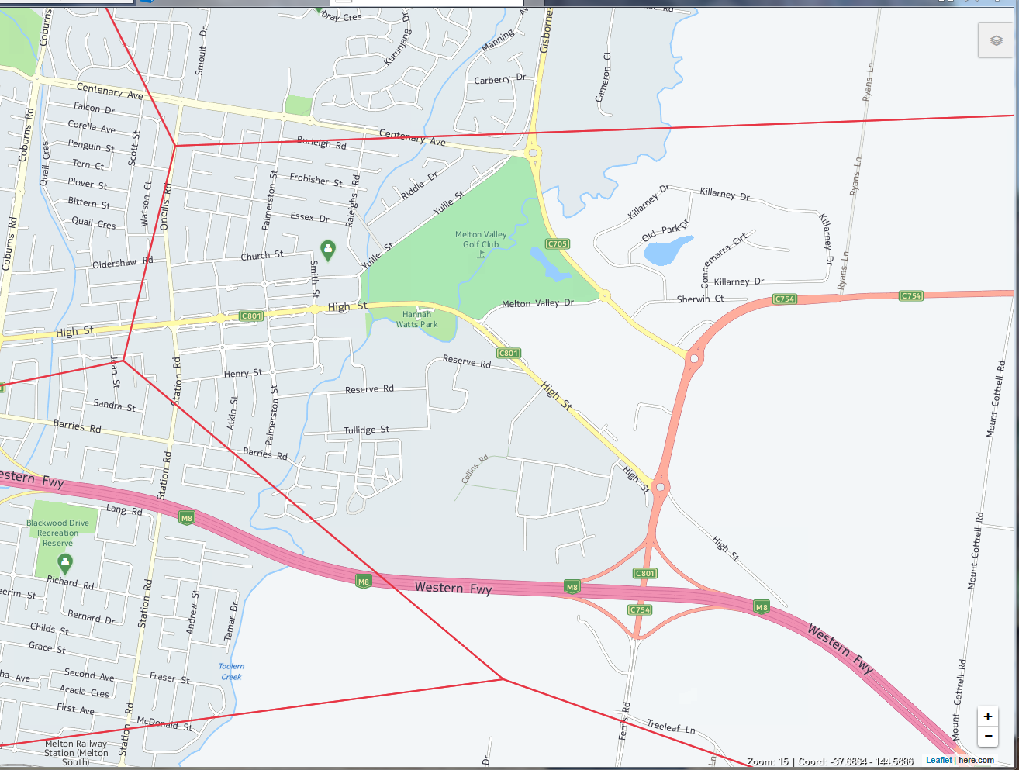

Ratified at School Council on 19th June 2024

